**FASTrack Inc.**

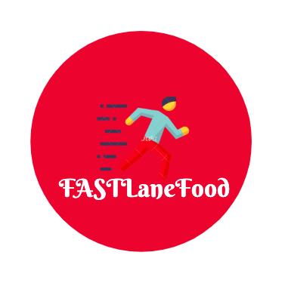

**FASTLaneFood**

**Software Requirements Specification**

**For Online Restaurant System**

**Version 1.0**

|  |  |  |
| --- | --- | --- |
| FASTLaneFood | Version: | 1.0 |
| Software Requirements Specification | Date: 21/Oct/19 | |
| First Draft |  |  |

**Revision History**

|  |  |  |  |
| --- | --- | --- | --- |
| **Date** | **Version** | **Description** | **Author** |
|  |  |  |  |
| 21/Oct/19 | 1.0 | First rough draft of FastLaneFood | Hasibul Islam  Eftekher Husain  Shahan Rahman  Jung Tae Lee |
|  |  |  |  |
|  |  |  |  |
|  |  |  |  |
|  |  |  |  |

|  |  |  |  |  |
| --- | --- | --- | --- | --- |
| FASTLaneFood | | | Versio: | 1.0 |
| Software Requirements Specification | | | Date: 21/Oct/19 | |
| First Draft | | |  |  |
|  |  | **Table of Contents** |  |  |
| 1. | Introduction | |  | 3 |
|  | 1.1 | Purpose |  | 3 |
|  | 1.2 | Scope |  | 3 |
|  | 1.3 | Definitions, Acronyms, and Abbreviations |  | 4 |
|  | 1.4 | References |  | 4 |
|  | 1.5 | Overview |  | 5 |
| 2. | Overall Description | |  | 6 |
|  | 2.1 | Assumptions and Dependencies |  | 6 |
|  |  |  |  |  |
| 3. | Specific Requirements | |  | 7 |
|  | 3.1 | Use-Case Reports |  | 7 |
|  | 3.2 | Supplementary Requirements |  | 8 |
| 4. | Supporting Information | |  | 12 |

|  |  |  |
| --- | --- | --- |
| FASTLaneFood | Version: | 1.0 |
| Software Requirements Specification | Date: 21/Oct/19 | |
| First Draft |  |  |

**Software Requirements Specification**

**1.** **Introduction**

This​ ​design​ ​report​ ​will​ ​give​ ​an​ ​overview​ ​of​ our ​design​ ​for​ ​the​ ​entire​ ​online restaurant system.​ ​The​ ​purpose​ ​and​ ​scope​ ​will​ ​be​ ​clarified​ ​along​ ​with​ ​key​ ​definitions​ ​for understanding​ ​rest​ ​of​ ​this​ ​document.

**1.1** **Purpose**

Our purpose with FASTLane Food is to give users depending on their role to either order or manage food services. The external feature of this application for a customer is to order food from a restaurant and have it delivered to them in the quickest way and cheapest price. The design constraints for FASTLane Food is that the application will not have a large enough database to hold a vast amount of users. In addition, another constraint is that to simplify geolocation tracking, deliveries will be at random in price and route status. Also restaurants and menus will not be realistically portrayed in the real world. The development of FASTLane Food will be written in Python and run through an ide.

**1.2** **Scope**

The purpose of the online restaurant system is to ease food ordering and create a convenient and easy-to-use application for consumers trying to purchase food from restaurants. The system is based on a relational database with its ordering functions and management functions. Above all, we hope to provide a great consumer experience with the best pricing available! The use case for a customer will be shown with our mockup of our application. (End Of Report)

**1.3** **Definitions, Acronyms, and Abbreviations**

Definitions:

**Name of Project**

* FLF - FASTLaneFood

**Types of Users**

* **Customer** - Who can order, pay and evaluate food and delivery people; there are 3 types of customers for each store: visitors, registered customers and VIPs, who received different prices—highest for visitors and lowest for VIPs. One customer can be a VIP for one store, while a mere visitor for another.
* **Manager** - For each store who decides commissions of salespeople dealing with supplies, pays of cooks and delivery people, and handles complaints and managements of customers.
* **Delivery Person** - Who bid on deliveries, decide routes to and for the restaurant to the customer, and evaluate customers.
* **Salesperson** - Who deal with suppliers for the best food supplies with best prices, each store have at least two sales people.
* **Cook** - Who determine the supplies qualities, menus and prices of different food items, each store have at least two cooks

**Types of Customers**

* Visitor
* R.C. - Registered Customers
* V.I.P - Very Important Person

# **1.4 References**

“Study Reveals How People Use Food Delivery Apps.” Food Supplier & Distributor | Restaurant Supply, 2019, https://www.usfoods.com/our-services/business-trends/2019-food-delivery-statistics.html.

Manlapas, Michael, and Don Davis. “How Consumers View Online Delivery Options.” Digital Commerce 360, 25 July 2018, https://www.digitalcommerce360.com/2018/07/25/how-consumers-view-online-delivery-options/.

"ResearchAndMarkets.com Offers Report: Future of Global Online Food Delivery Services Market." Entertainment Close-up 13 Oct. 2019: NA. Business Insights: Global. Web. 2 Nov. 2019.

"The global online on-demand food delivery services market at a CAGR of over 15% during the forecast period." Plus, Company Updates 22 Oct. 2019: NA. Business Insights: Global. Web. 2 Nov. 2019.

**1.5 Overview**

* **Study Reveals How People Use Food Delivery Apps:** The Us Food article is about statistics on how consumers crave a food delivery service. Similar food applications gave our group information on estimations of cost and distances for food and delivery routes.
* **How Consumers View Online Delivery Options:** While free shipping remains important, consumers increasingly want convenience, including being able to pick up orders at local stores or lockers. Consumers desire a personalized delivery system that works around their preferences. Loyalty programs with shipping perks are popular and desired by customers.
* **Future of Global Online Food Delivery Services Market:** Online food delivery is growing at a rapid pace all over the world due to the convenience, variety, and cost available at the touch of a button. Major cities and urban centers have been the epicenter of this evolution, especially because of the increased penetration of smartphones and widespread internet connectivity. Online food delivery is already having a huge impact on the dine-in restaurant business. But to really understand the growing clout of the online food delivery business, one need only follow the story of one company - UberEATS. Launched in 2014, the company has grown astronomically across the world on the back of its popular elder sibling, Uber. Uber Eats itself is currently valued at a very healthy $20 billion, registers revenues of $1.4 billion annually, has a presence in more than 670 cities on six continents, and delivers almost a billion meals every year.
* **The global online on-demand food delivery services market at a CAGR of over 15% during the forecast period:** Consumers increasingly prefer to order food through online food delivery applications owing to the rapid global penetration of e-commerce and Internet-enabled devices. The shift from conventional on-premise dining to ordering online is also attributed to factors such as convenience, low costs, and the availability of a large variety of dishes online. This growing consumer demand for convenient food ordering will lead to the expansion of the global online on-demand food delivery services market at a CAGR of over 15% during the forecast period. Social media is increasingly being leveraged by vendors as a critical channel for marketing and promotional activities. Established vendors in the market have an active social media presence through which they promote their online delivery services, food, and restaurants. Moreover, social media provides a key avenue for vendors to connect and engage directly with their customers. This development is expected to have a positive impact on the overall market growth.

**2.** **Overall Description**

The product perspective of FastLaneFood is that since it is a local application, data stored such as restaurant information and actors will be made-up for simplicity. The whole objective of this project to show that an online restaurant system can be created and have different users interact with this application. Since we have 5 different types of users we want to make sure each respectively can view a different version of the application and complete their task. Constraints of this project as mentioned before are not using real data to pull such as restaurants, also since our team does not have the resources to simulate certain actions, we will pretend certain actions are complete in random time; such as delivery. This project is dependent on having a database that stores all users and app related data.

**2.1** **Assumptions and Dependencies**

The dependency of this project is that FastLaneFood will use fake information and depend on a local database. One assumption we are making with this project is that food delivered will be automatically processed once the order is complete to show the demo of the application.

|  |  |  |
| --- | --- | --- |
| FASTLaneFood | Version: | <1.0> |
| Software Requirements Specification | Date: 21/Oct/19 | |
| First Draft |  |  |

**3.** **Specific Requirements**

This specific requirements for this project is that the customer can order food through our application. For the customer there are 3 tiers for them which are described in 1.3. Then a Manager for each store can decide the commission for a sales person, cook and delivery person. They also handle all complaints. The delivery person is the person who gives the food to the customer and can rate the customers behavior. Next, the sales person gets supplies for the cook and the cook can rate the supplies and create new meals. These five users must be in the project and have an option to rate someone which is shown in 3.2. In addition to the main part of this project we need to build a function that allows the visually impaired to order food by voice commands. Lastly, our creative feature for this project is still in the air but we are leaning towards making this project online so that any computer can enter the url and access this application.

**3.1** **Use-Case Reports**

The use cases for this project are defined in five ways you are able to use this application. Since there are five types of users in this application we have respective actions for all these users. Since they all require different actions on this app, we need to build a different user interface for each user. In section 4, we show the mockup of a customer and each stage they will go through. Since this is the main way the business makes money this feature must be close to perfect and have a seamless experience. Then for the other four we will have a more planned out outline on how their user interface will look like in the next few drafts.

**3.2** **Supplementary Requirements**

***The Diagrams below show the rough logical process of how the application will run and flow.***

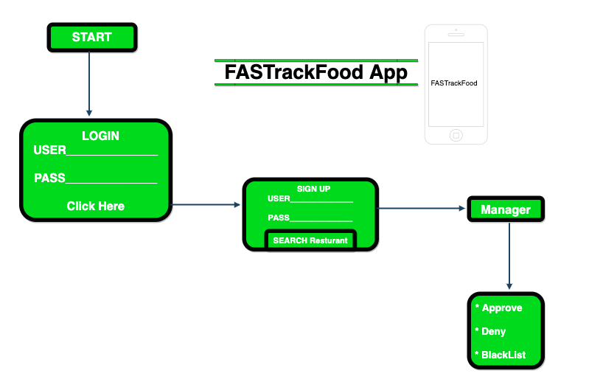

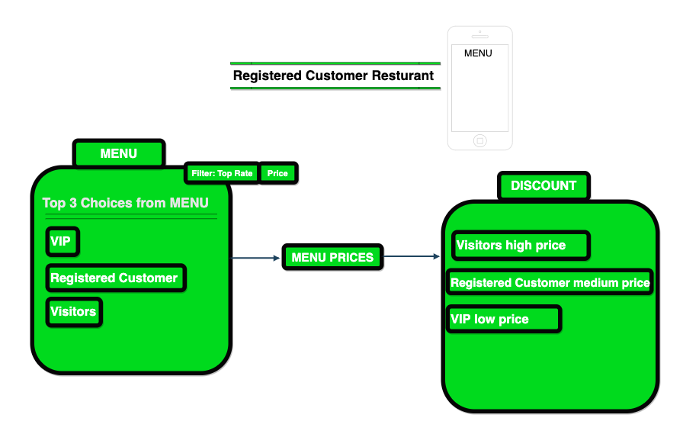

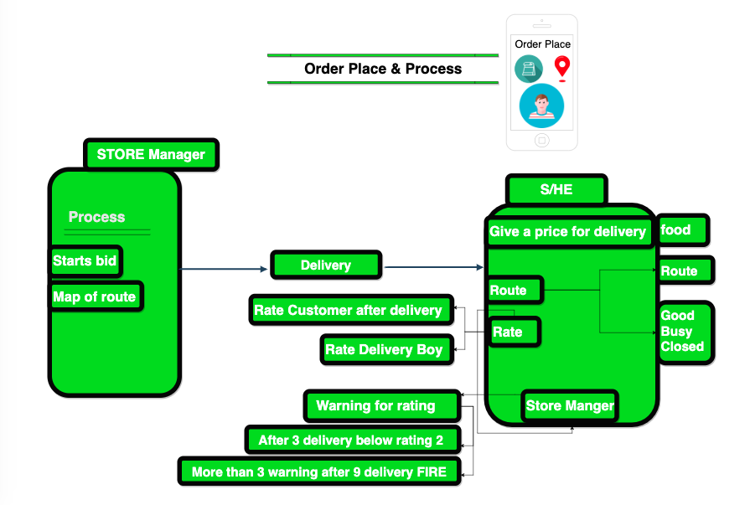

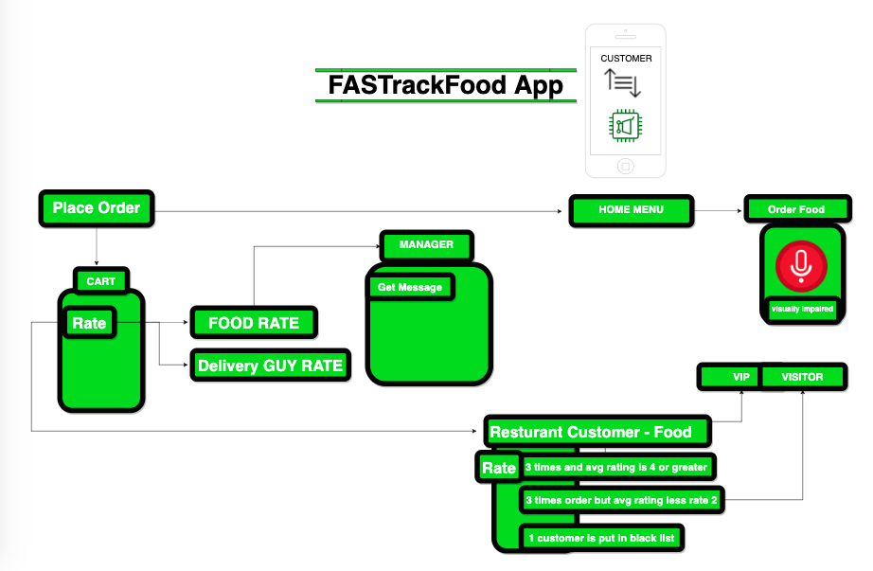

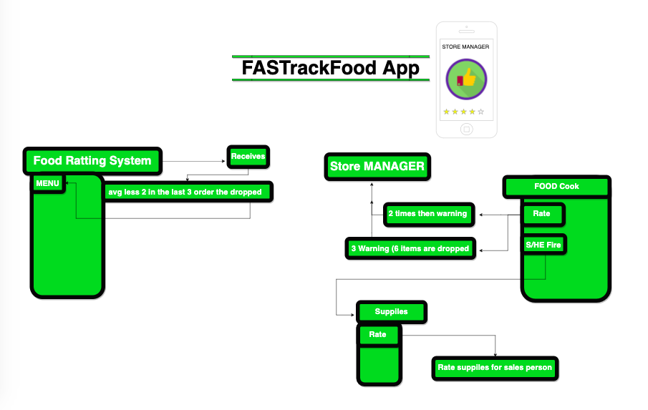

**4.** **Supporting Information**

**The images below show the mockup of our application.**

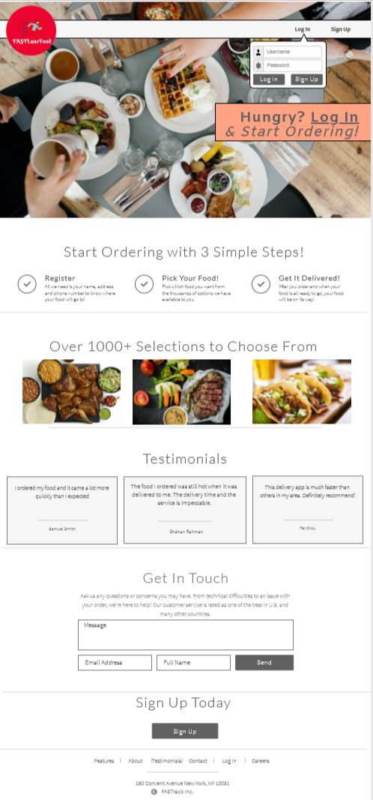

(This is the landing page of FastFoodLane with the login)

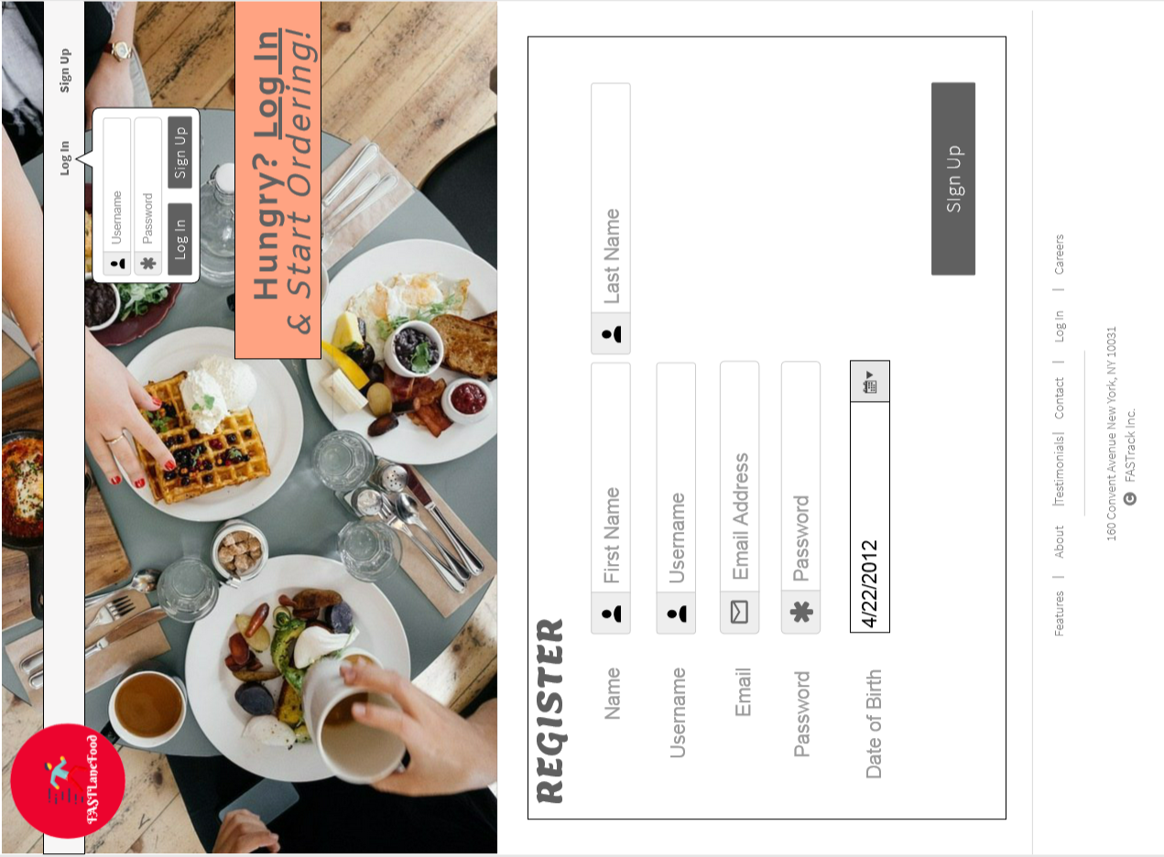

(This is registering page)

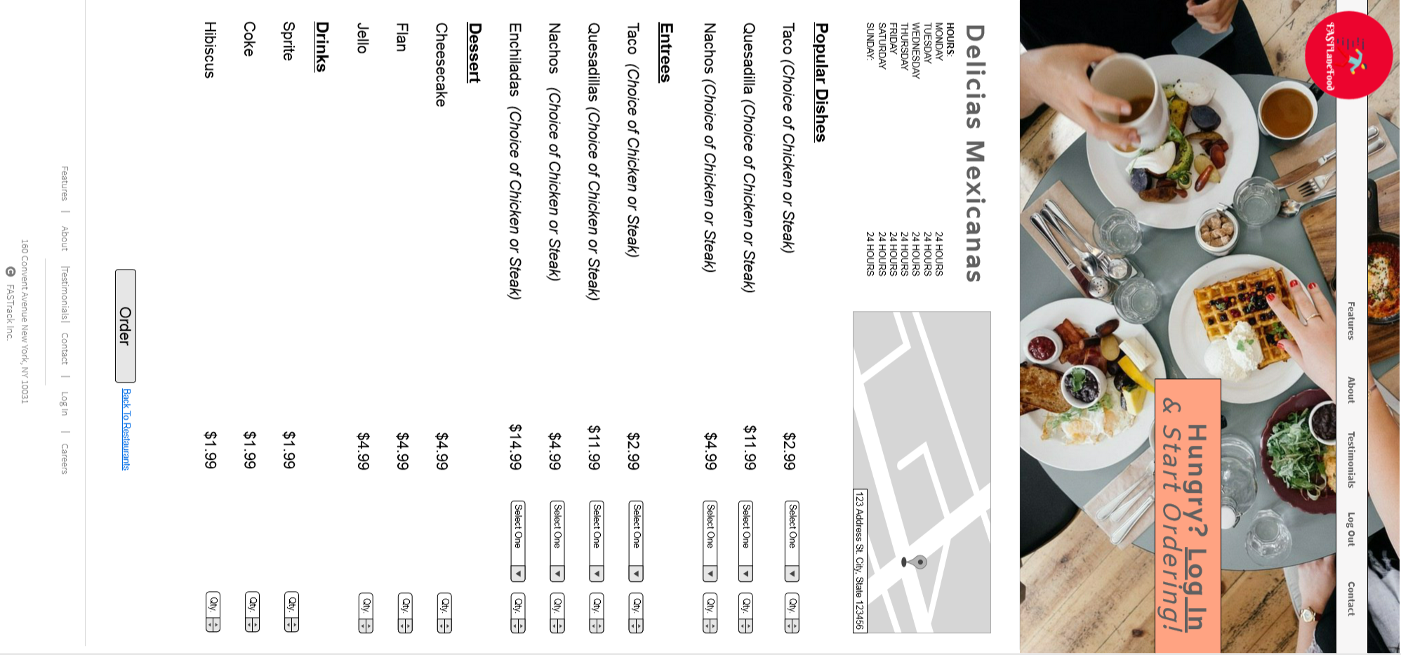

(This is when the customer is ordering on the restaurant's menu)

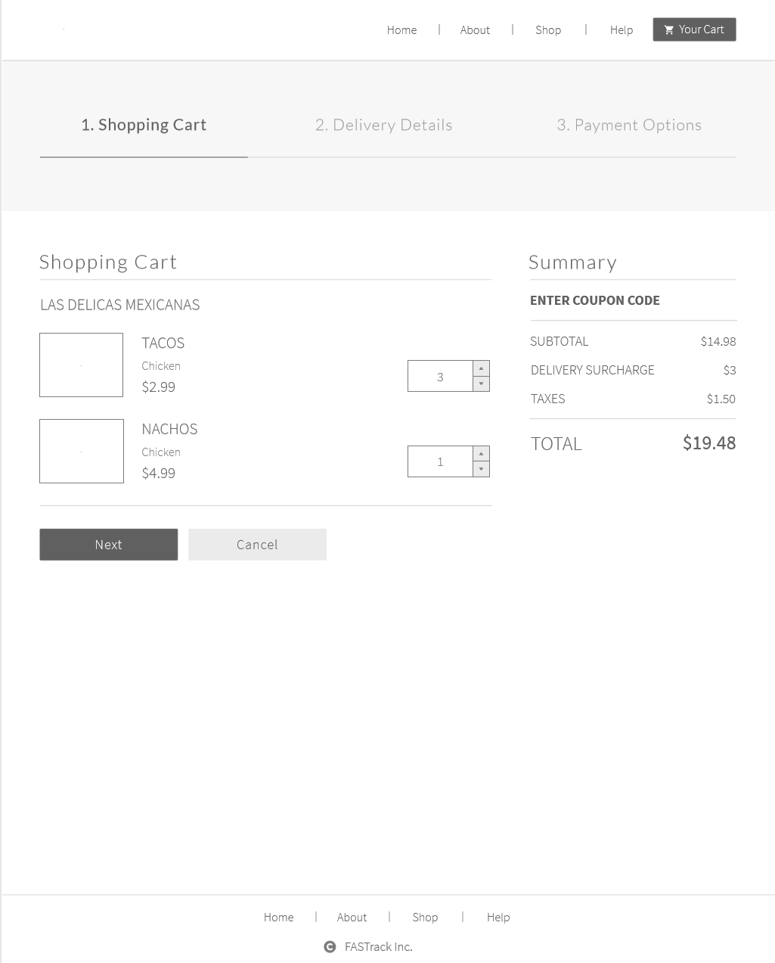

(This is the ordering page)

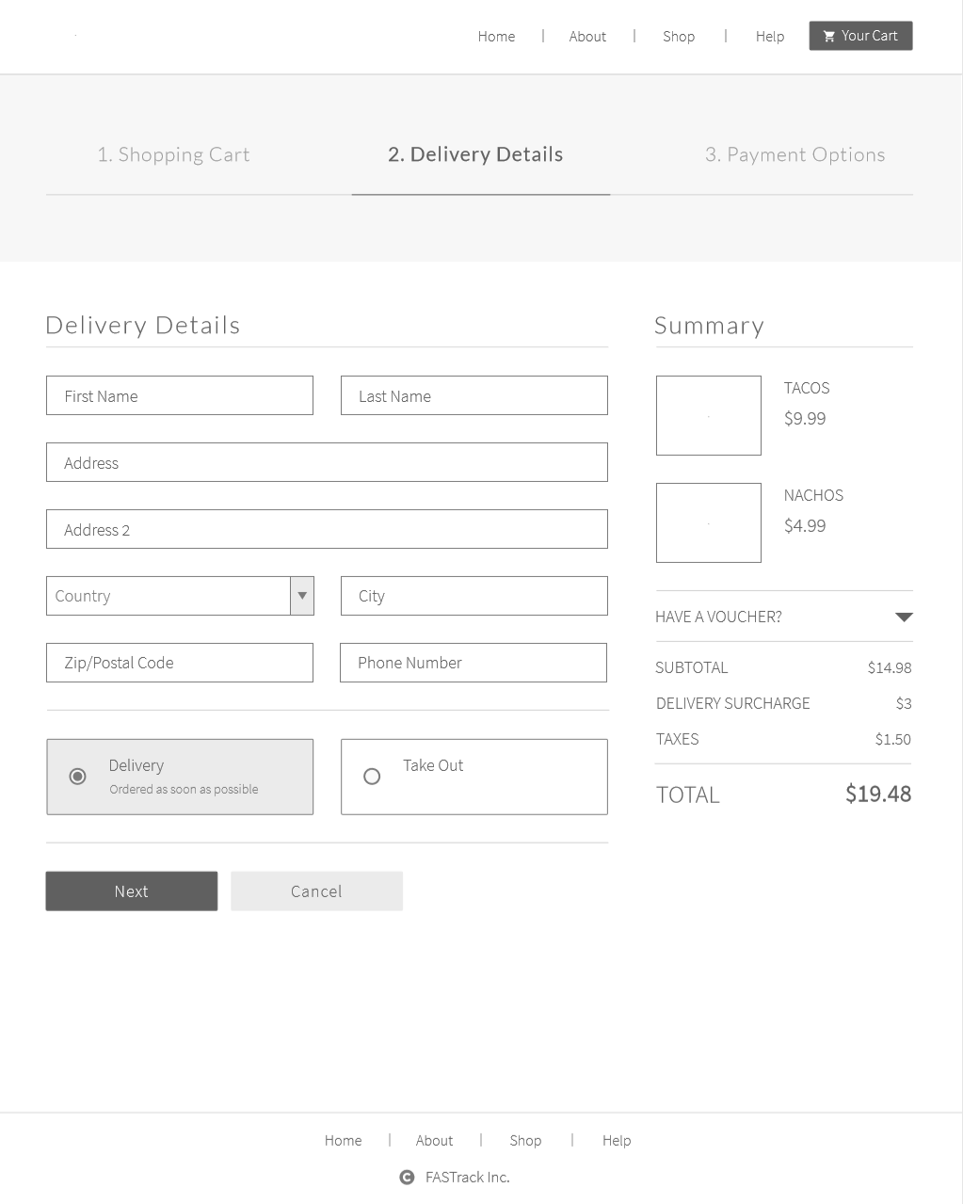

(This is the delivery information when the customer enters their location)

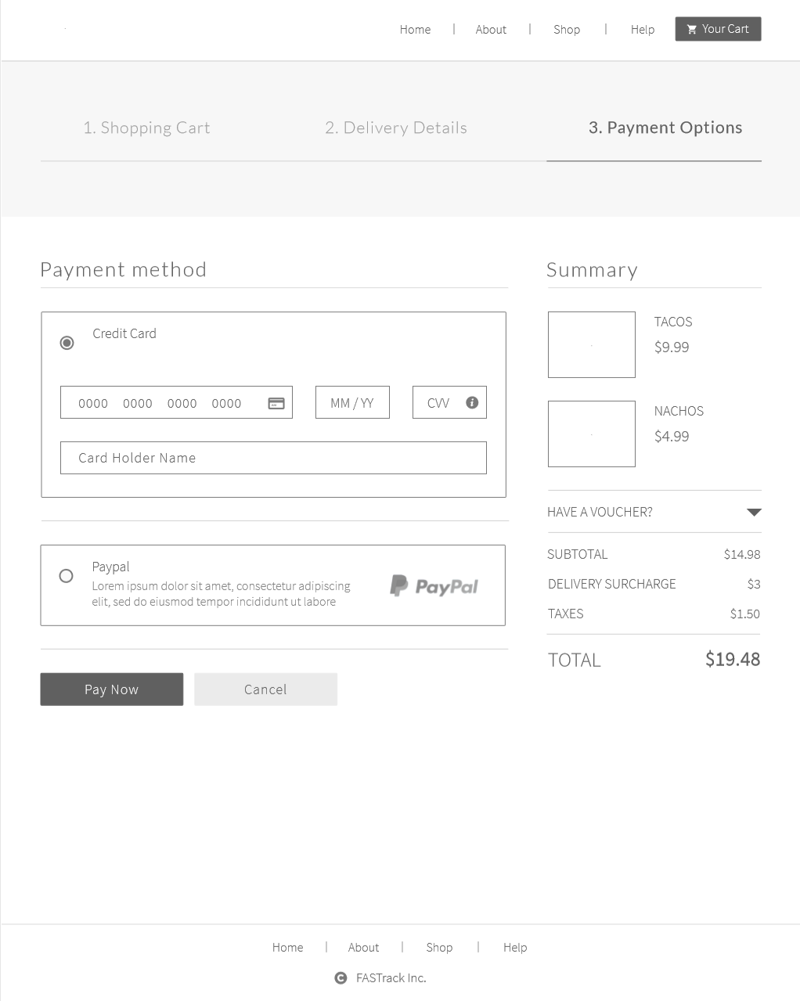

(This is the payment information)

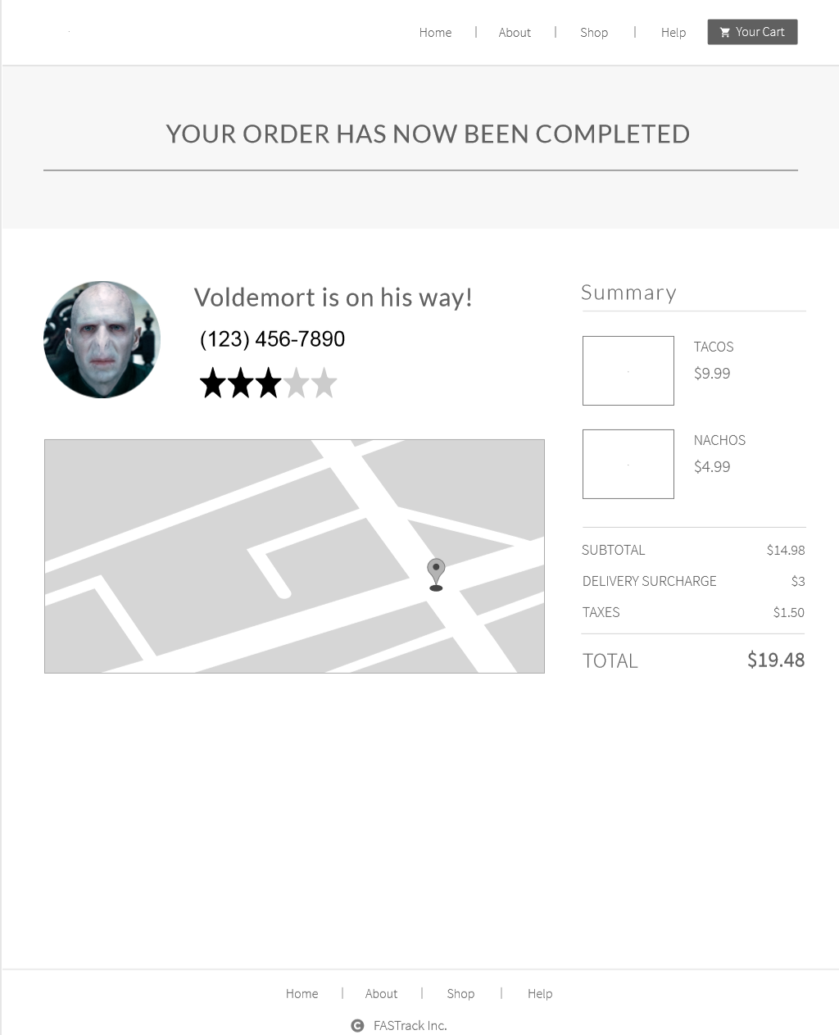

(This is the last process when the food is delivered and ratings are complete)